**English**

**User Guide for Monitoring System**

**1. Required Knowledge for Installation**

* **Docker**: A software that runs containerized servers without requiring extensive installation.
* **Ubuntu**: An open-source operating system similar to Windows and macOS, lightweight for server deployment.
* **Terminal**: A tool for interacting with Ubuntu.
* **GitHub**: An online service for source code storage.
* **Git**: Software used to quickly download projects.
* **Project Repository**: [DeepInsight GitHub](https://github.com/Codemind-Developement/DeepInsight)

**2. Server Installation (Data Storage Center)**

**2.1 Installation on Windows**

**A. Docker Installation**

* Download Docker Desktop from [Docker Official Website](https://www.docker.com/products/docker-desktop/).

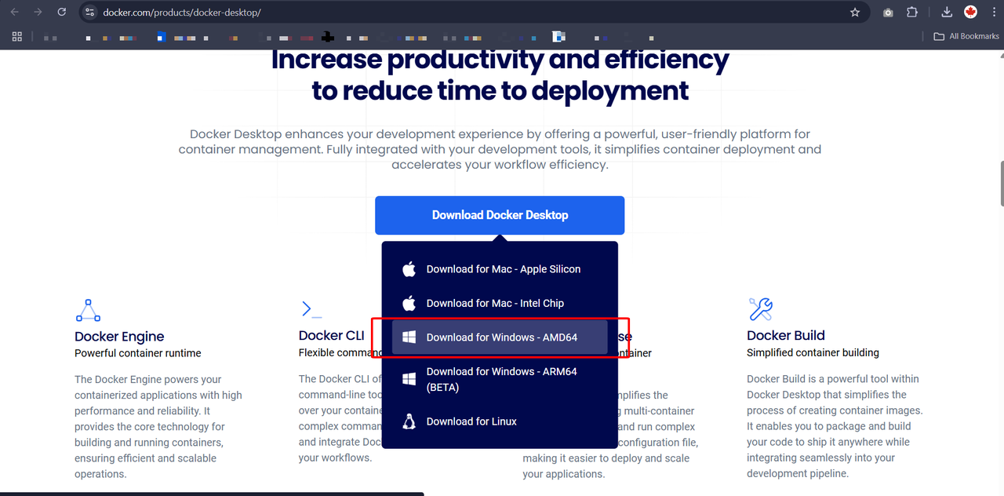

* Choose the appropriate version (typically Windows AMD for Intel-based chips).
* After downloading, double-click the installation file and follow the instructions.

**B. Git Installation**

* Download Git from [Git Official Website](https://git-scm.com/downloads).

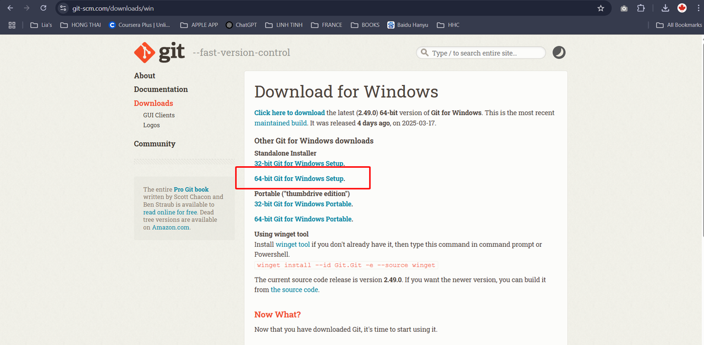

* Install the file and follow the setup process.

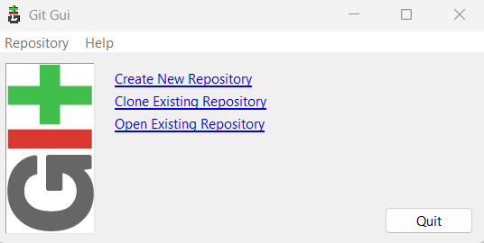

Choose "Quit" and done.

* Verify installation: Open **CMD** (Press Start > Type CMD > Enter) and run:

|  |
| --- |
| Plain Text git --version |

* (Should return a version number, e.g., 3.4.6.)

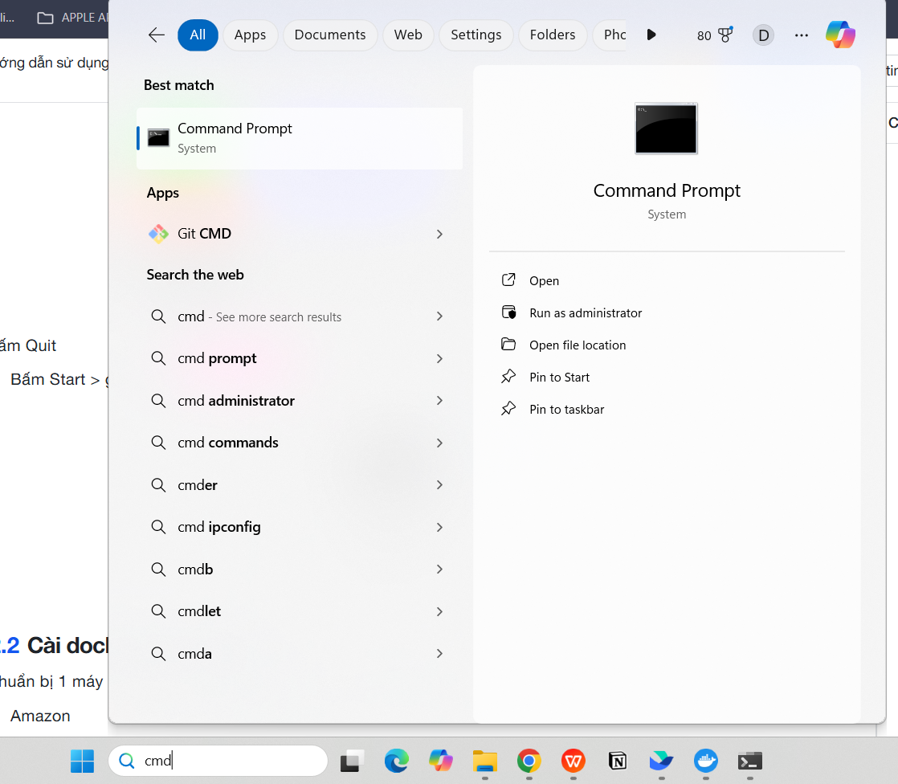

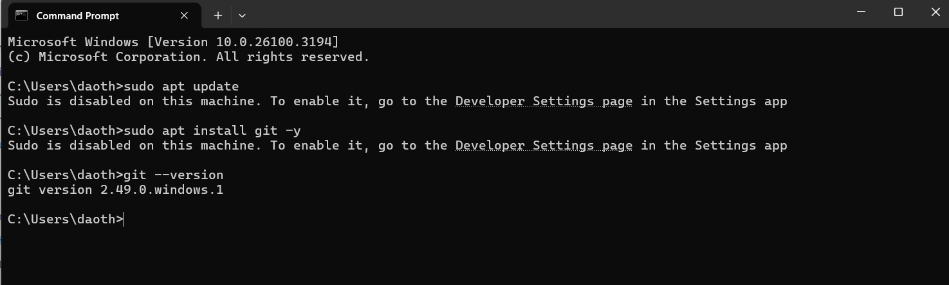

**C. Project Setup**

* Clone the project repository:

|  |
| --- |
| Plain Text git clone https://github.com/Codemind-Developement/DeepInsight.git |

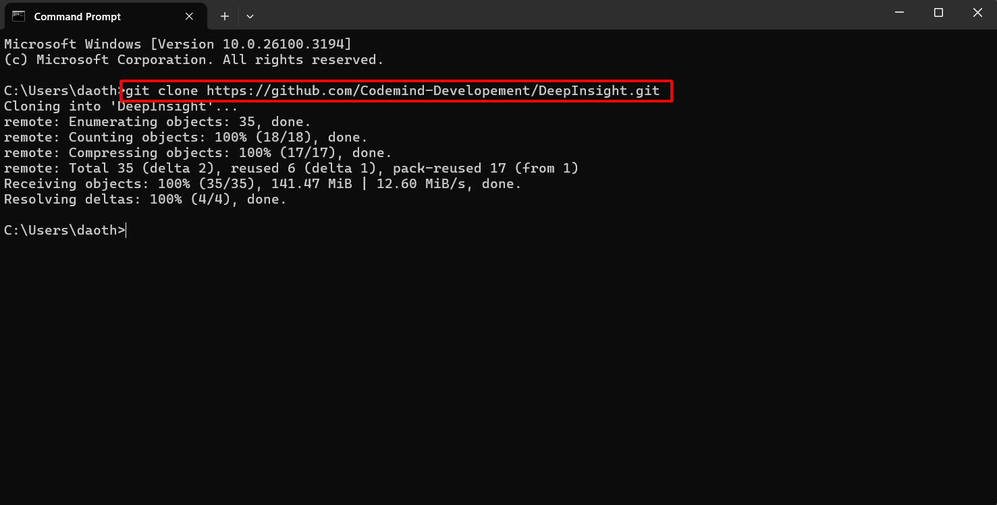

* Retrieve the server IP:

|  |
| --- |
| Plain Text ipconfig |

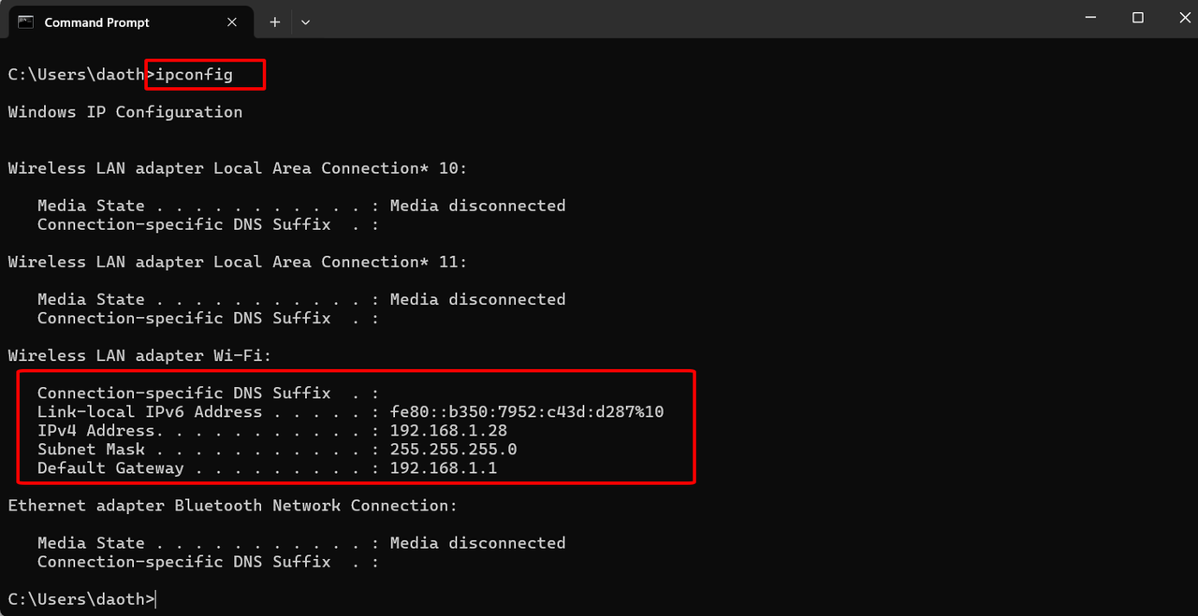

* Start the system:

|  |
| --- |
| Plain Text docker compose --env-file .env up -d |

**2.2 Installation on Ubuntu**

**A. Docker Installation**

* Set up an Ubuntu server (options: AWS, Alibaba Cloud, or self-hosted).
* Follow the [Docker Ubuntu Installation Guide](https://docs.docker.com/engine/install/ubuntu/).
* Run the following commands:

|  |
| --- |
| Plain Text sudo apt-get update sudo apt-get install ca-certificates curl sudo install -m 0755 -d /etc/apt/keyrings sudo curl -fsSL https://download.docker.com/linux/ubuntu/gpg -o /etc/apt/keyrings/docker.asc sudo chmod a+r /etc/apt/keyrings/docker.asc |

|  |
| --- |
| bash echo \ "deb [arch=$(dpkg --print-architecture) signed-by=/etc/apt/keyrings/docker.asc] https://download.docker.com/linux/ubuntu \ $(. /etc/os-release && echo "${UBUNTU_CODENAME:-$VERSION_CODENAME}") stable" | \  sudo tee /etc/apt/sources.list.d/docker.list > /dev/null sudo apt-get update |

* Install Docker:

|  |
| --- |
| Plain Text sudo apt-get install docker-ce docker-ce-cli containerd.io docker-buildx-plugin docker-compose-plugin |

* Configure Docker user permissions:

|  |
| --- |
| Plain Text sudo groupadd docker sudo usermod -aG docker $USER newgrp docker |

**B. Git Installation**

* Install Git:

Run the following command in the Terminal:

|  |
| --- |
| Plain Text sudo apt update sudo apt install git -y |

* Verify installation:

|  |
| --- |
| Plain Text git --version |

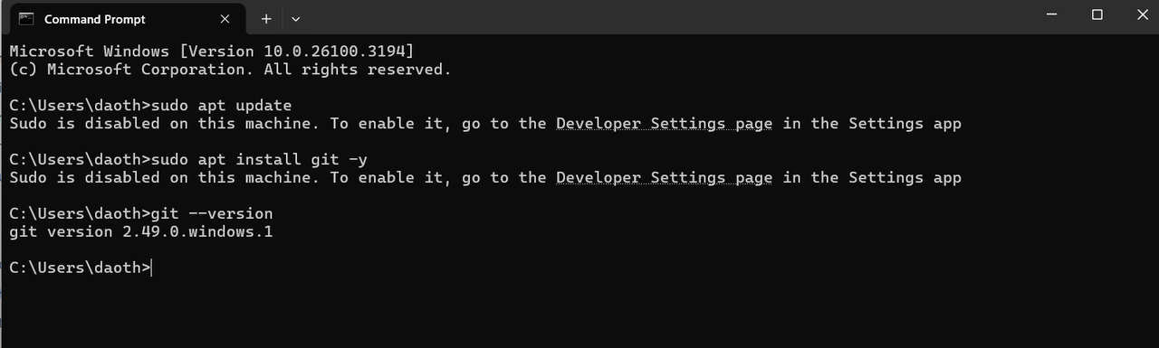

**C. Project Setup**

* Clone the project repository:

|  |
| --- |
| Plain Text git clone https://github.com/Codemind-Developement/DeepInsight.git |

* Retrieve the server IP:

|  |
| --- |
| Plain Text curl ifconfig.me |

* Start the system:

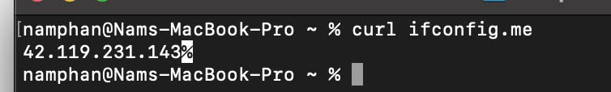

|  |
| --- |
| Plain Text docker compose --env-file .env up -d |

**3. Accessing the Management Interface**

Use a computer to view the management interface on the server.

We need to configure domain reference on the device that wants to access the server.

* Retrieve the server IP for configuration by running the following command to get the server's IP address.
* Retrieve the server IP:

|  |
| --- |
| Plain Text curl ifconfig.me |

* Modify the **hosts file** for domain reference:
* **Windows**:

Open Notepad with Administrator rights:

* Click **Start**, type **Notepad**, then **right-click** on Notepad and select **Run as administrator**.

Open the **hosts** file:

* In Notepad, click **File > Open**.
* Navigate to this folder: C:\Windows\System32\drivers\etc\.
* **Important**: Change the file type to **“All Files”** to see the hosts file.

Add the following line at the end of the file:

|  |
| --- |
| bash php-template |

Copy code

<IP-server> deepinsight_api

*(Replace <IP-server> with the actual server IP, e.g., 192.168.1.100.)*

Save the file and restart your web browser or terminal if needed.

* **Linux/macOS**:
* Open the **Terminal**.
* Run the following command:

|  |
| --- |
| Plain Text sudo nano /etc/hosts |

* Add this line at the end of the file:

|  |
| --- |
| Plain Text <IP-server> deepinsight_api |

* *(Replace <IP-server> with the actual server IP.)*
* Press **Ctrl + O** to save, then **Enter** to confirm.
* Press **Ctrl + X** to exit.
* After accessing the management page, go to:

|  |
| --- |
| Plain Text http://<IP-server>:19007/settings/configuration |

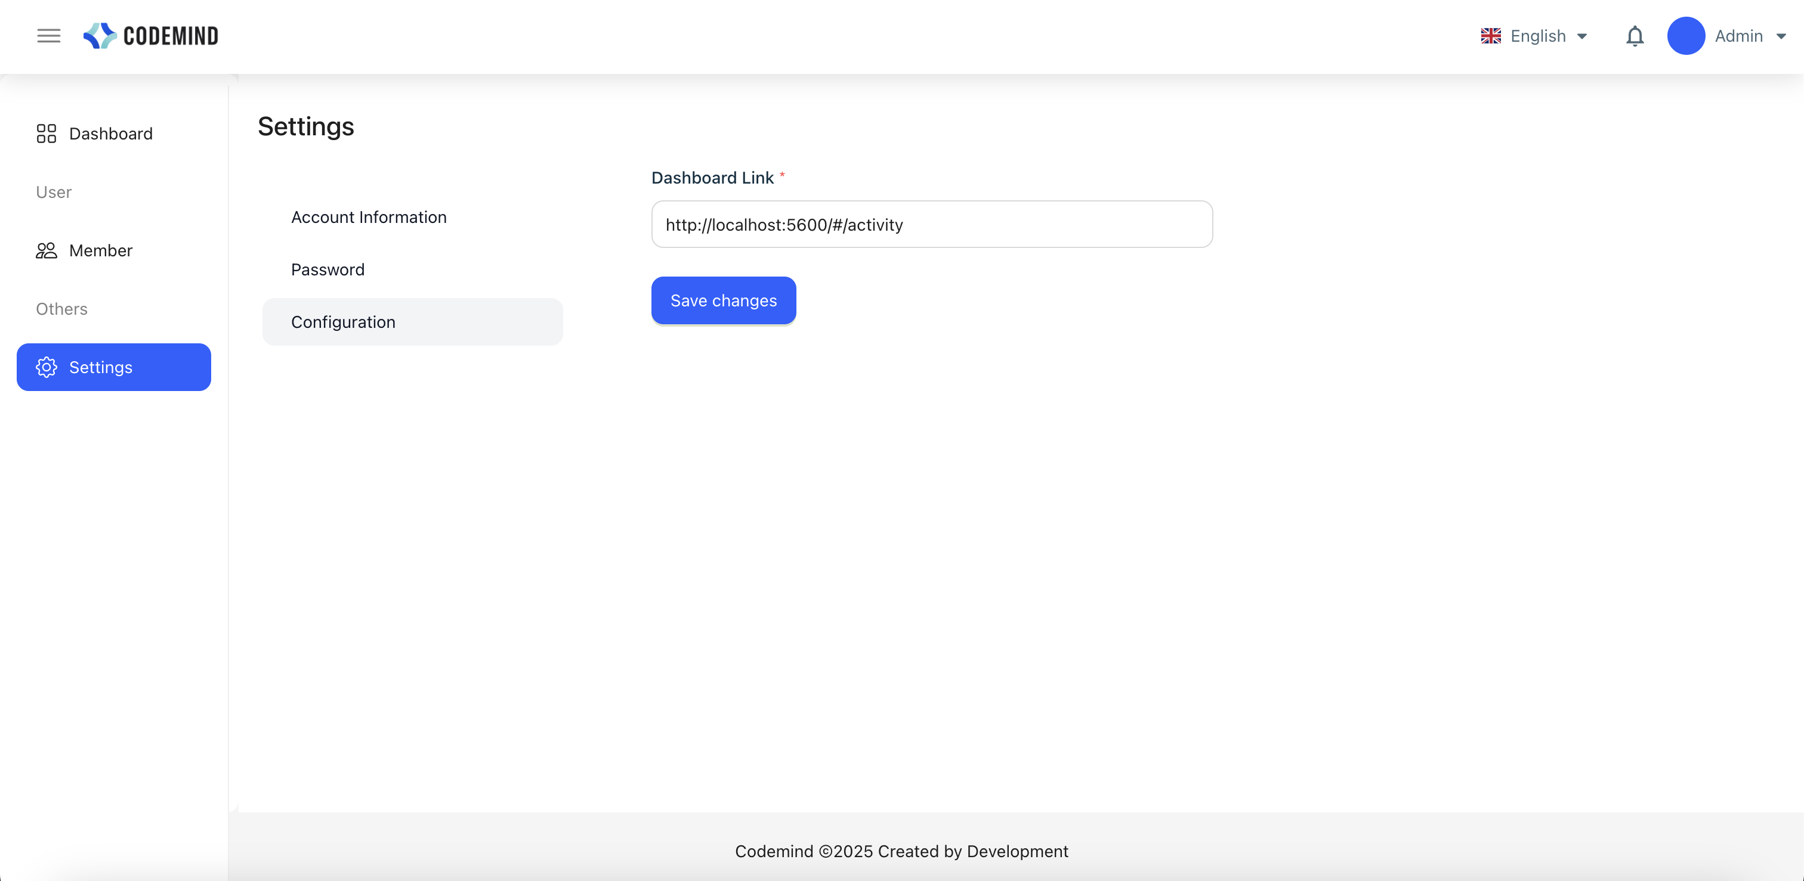

**4. Installing Monitoring Software for Client Machines**

**4.1 Installing Activity Watch**

* Go to the **"clients"** folder inside the **"DeepInsight"** project folder to download **"activitywatch-v0.13.2-windows-x86_64-setup.exe"** (client monitoring is only available for Windows).  
  [Download link](https://github.com/Codemind-Developement/DeepInsight/tree/main/clients).

**4.2 Installing CodeMind Client**

* Go to the **"clients"** folder inside the **"DeepInsight"** project folder to download **"CodemindClient.exe"** for monitoring client machines.  
  [Download link](https://github.com/Codemind-Developement/DeepInsight/tree/main/clients).

**Kafka IP Configuration:**

* Enter the retrieved **server IP** as follows:
* Get the server IP by running this command:

|  |
| --- |
| Plain Text curl ifconfig.me |

* **Username:** admin
* **Password:** mua1P4bRFd

**Configure Client to Auto-Start on Boot:**

1. Open **Task Scheduler**:

* Press **Win + R**, type taskschd.msc, and press **Enter**.

1. Select **Create Basic Task**.
2. Name it **MyKafkaSync**.
3. In the **Trigger** step, select **When the computer starts**.
4. In the **Action** step, select **Start a program**.
5. Under **Program/script**, click **Browse...** and select **CodemindClient.exe**.
6. Click **Finish** to save the configuration.

**4.3 Installing Central Client**

* Visit: http://<IP-server>:19003/.
* Click **Create one** to add an account.

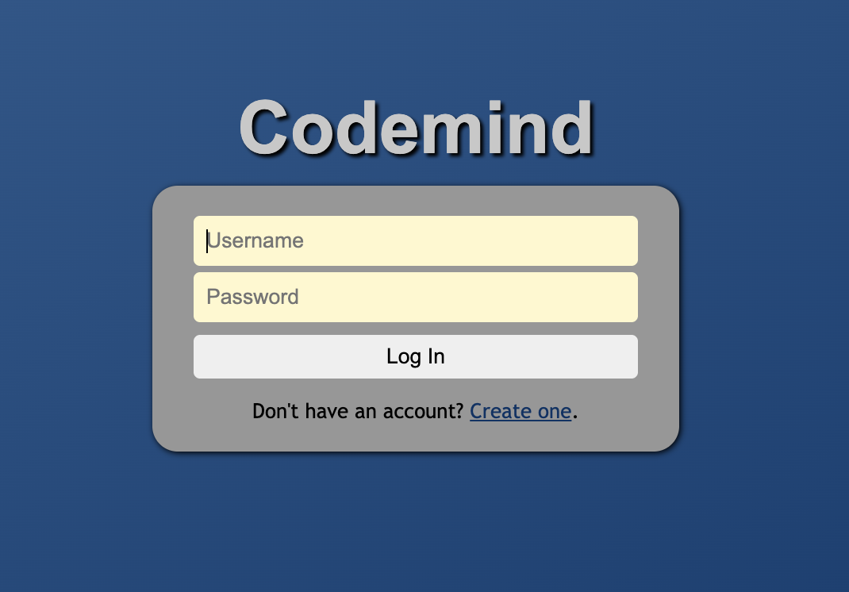

* Enter required details and create an account.

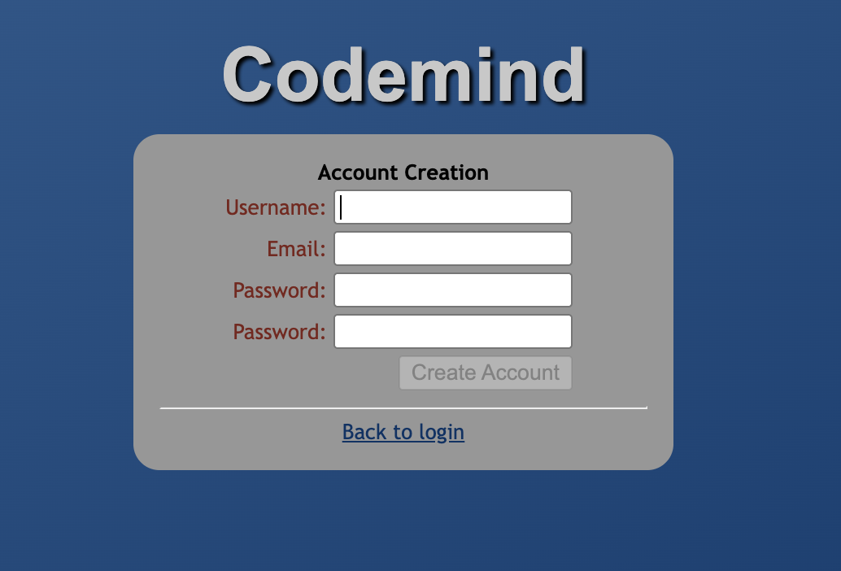

* Log in and click **click here to create a device group**.

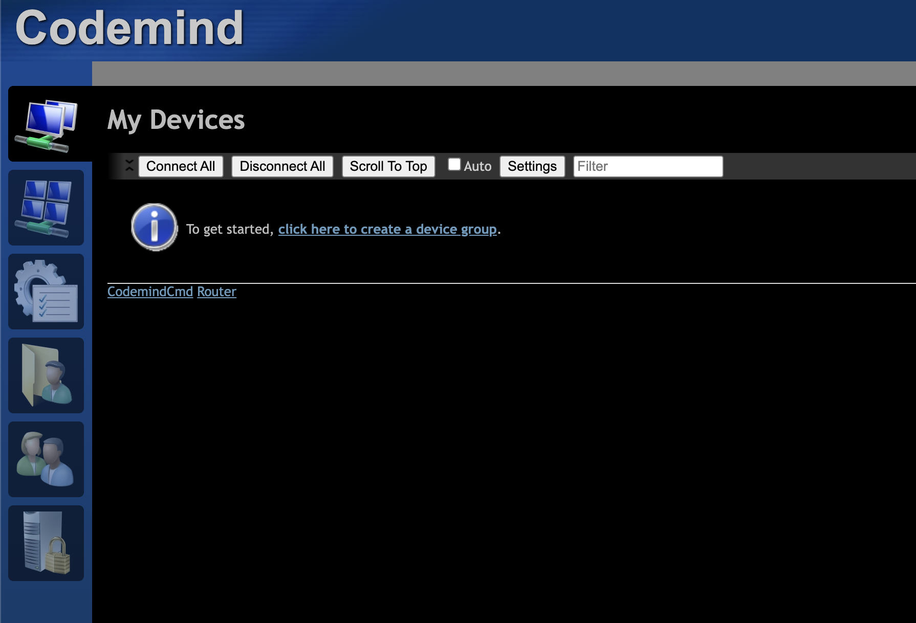

* Enter a name and click **OK**.

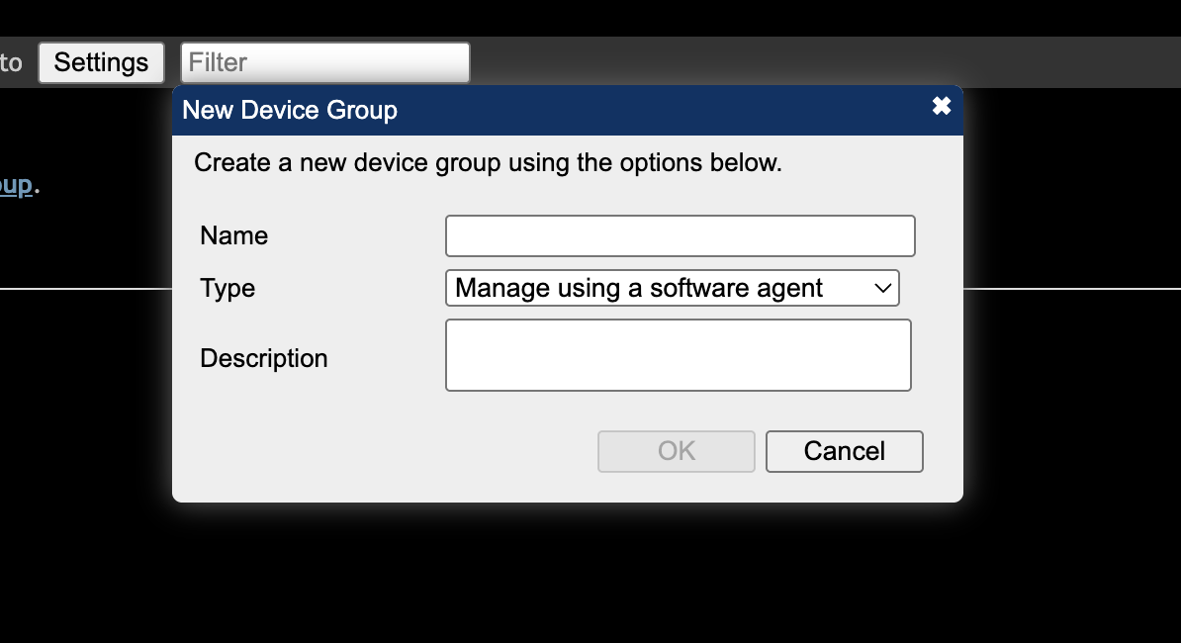

* Click **Add Agent** to install the client agent.

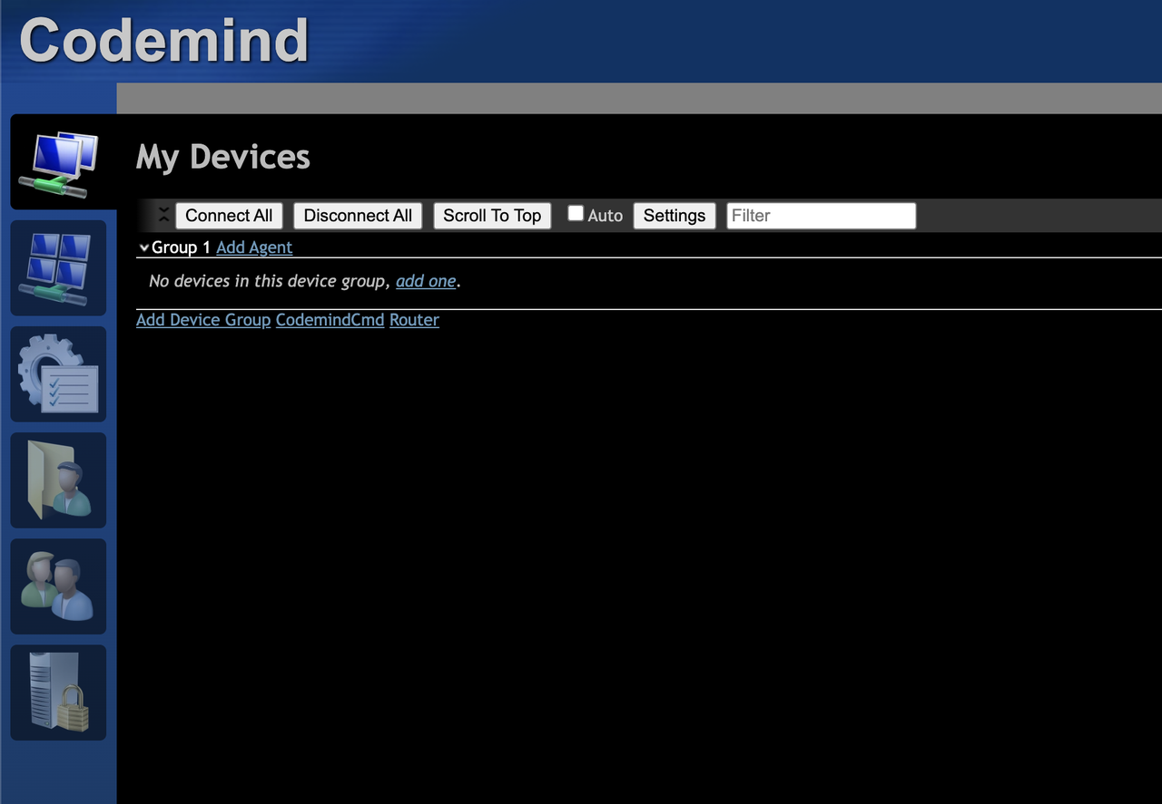

* Select the installation file to install on the client.

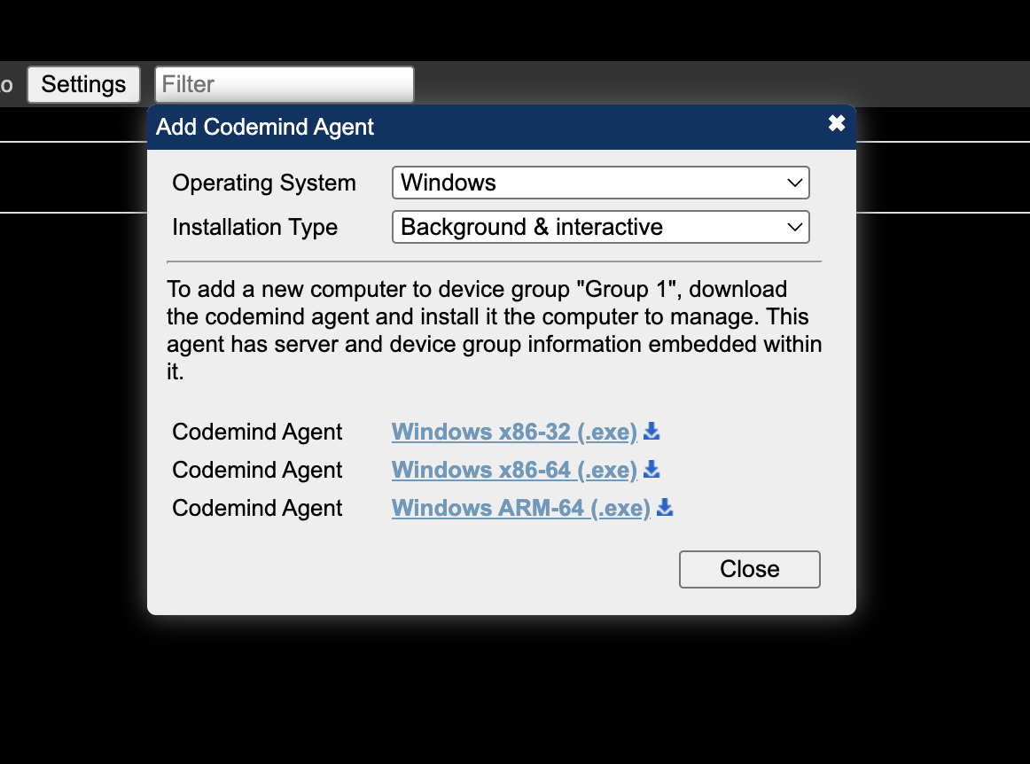

**5. System Operation**

**5.1 Central Management**

* For more details, go to the **Instruction** folder in the **DeepInsight** project and open the file **Central instruction - 控制指南.xlsx**.  
  [View file](https://github.com/Codemind-Developement/DeepInsight/blob/main/instruction/Central%20instruction%20-%20%E6%8E%A7%E5%88%B6%E6%8C%87%E5%8D%97.xlsx).
* Check the sections **"Client"** and **"Admin"**.

**5.2 Admin Configuration**

Go to the **"Member"** menu on the left panel or access:

Copy code

|  |
| --- |
| bash https://<IP-server>:19007/member-admin |

Click **"Add member"** to add a new monitoring user.

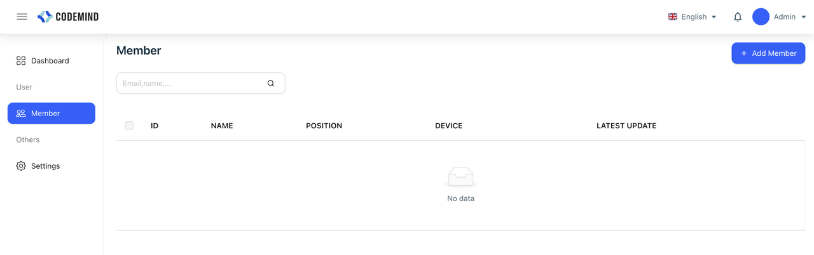

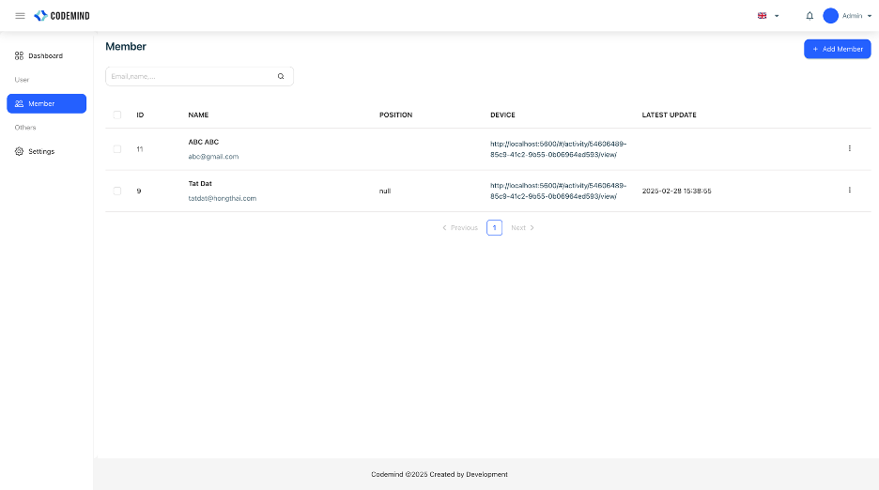

* After that, you can click on the **"Device"** link on the list page to view the device specifications.

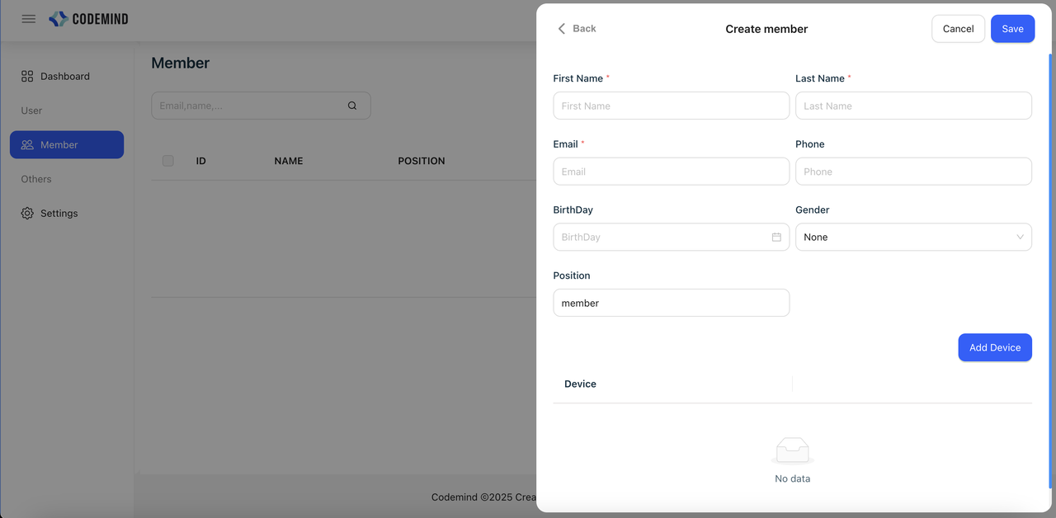

**5.3 Dashboard View**

* Go to the **Instruction** folder in the **DeepInsight** project and open the file **Setup user and dashboard - 设置用户和仪表盘**.  
  [View file](https://github.com/Codemind-Developement/DeepInsight/blob/main/instruction/Setup%20user%20and%20dashboard%20-%20%E8%AE%BE%E7%BD%AE%E7%94%A8%E6%88%B7%E5%92%8C%E4%BB%AA%E8%A1%A8%E7%9B%98.docx).

**中文**

**1. 安装前的必备知识**

* **Docker**：一种可以运行容器化服务器的软件，无需复杂安装。
* **Ubuntu**：一种类似于Windows和macOS的开源操作系统，轻量级，适用于服务器部署。

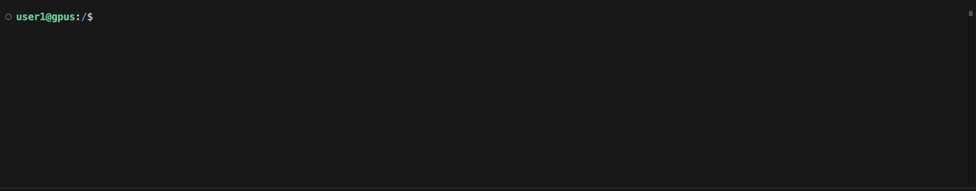

* **终端（Terminal）**：用于与Ubuntu交互的工具。
* **GitHub**：一个用于在线存储源代码的服务。
* **Git**：用于快速下载项目的工具。
* **项目存储库**：[DeepInsight GitHub](https://github.com/Codemind-Developement/DeepInsight)

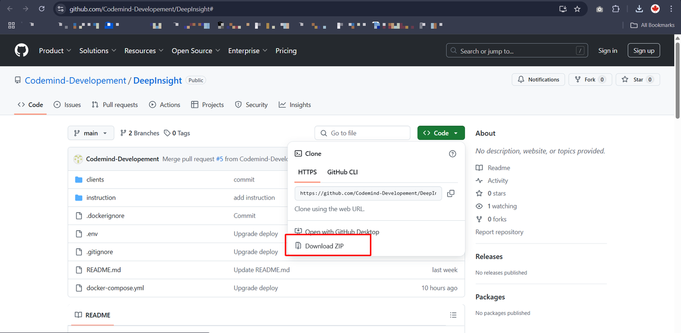

**2. 服务器端安装（数据存储中心）**

**2.1 Windows系统安装**

**A. 安装Docker**

* 从[Docker官方网站](https://www.docker.com/products/docker-desktop/)下载Docker Desktop。
* 选择适合的版本（通常为Windows AMD - Intel芯片）。



* 下载后，双击安装文件并按照说明进行操作。

**B. 安装Git**

* 从[Git官方网站](https://git-scm.com/downloads)下载Git。



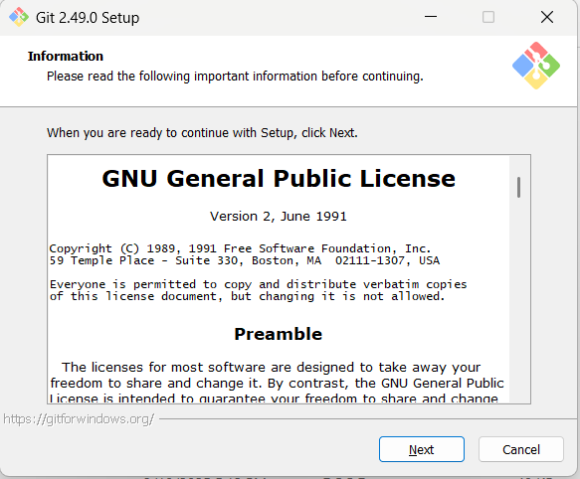



* 安装后，打开**CMD**（按**开始 > 输入CMD > 回车**），运行以下命令进行验证：

|  |
| --- |
| Plain Text git --version |

* （如果安装成功，会显示版本号，例如：3.4.6）。





**C. 项目设置**

* 克隆项目代码：

|  |
| --- |
| Plain Text git clone https://github.com/Codemind-Developement/DeepInsight.git |

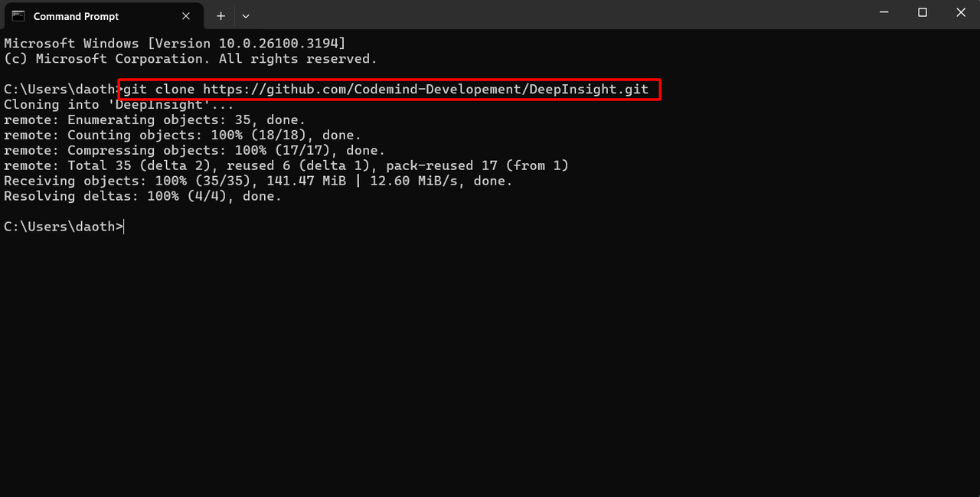

* 获取服务器IP地址：

|  |
| --- |
| Plain Text ipconfig |



* 启动系统：

|  |
| --- |
| Plain Text docker compose --env-file .env up -d |

**2.2 Ubuntu系统安装**

**A. 安装Docker**

* 需要一台Ubuntu服务器（可以选择AWS、阿里云或自建服务器）。
* 参考[Docker Ubuntu安装指南](https://docs.docker.com/engine/install/ubuntu/)。
* 运行以下命令安装必要环境：

|  |
| --- |
| Plain Text sudo apt-get update sudo apt-get install ca-certificates curl sudo install -m 0755 -d /etc/apt/keyrings sudo curl -fsSL https://download.docker.com/linux/ubuntu/gpg -o /etc/apt/keyrings/docker.asc sudo chmod a+r /etc/apt/keyrings/docker.asc |

|  |
| --- |
| bash echo \  "deb [arch=$(dpkg --print-architecture) signed-by=/etc/apt/keyrings/docker.asc] https://download.docker.com/linux/ubuntu \  $(. /etc/os-release && echo "${UBUNTU_CODENAME:-$VERSION_CODENAME}") stable" | \  sudo tee /etc/apt/sources.list.d/docker.list > /dev/null sudo apt-get update |

* 安装Docker：

|  |
| --- |
| Plain Text sudo apt-get install docker-ce docker-ce-cli containerd.io docker-buildx-plugin docker-compose-plugin |

* 配置Docker用户权限：

|  |
| --- |
| Plain Text sudo groupadd docker sudo usermod -aG docker $USER newgrp docker |

**B. 安装Git**

* 安装Git：

|  |
| --- |
| Plain Text sudo apt update sudo apt install git -y |

* 验证安装：

|  |
| --- |
| Plain Text git --version |



**C. 项目设置**

* 克隆项目代码：

|  |
| --- |
| Plain Text git clone https://github.com/Codemind-Developement/DeepInsight.git |

* 获取服务器IP地址：

|  |
| --- |
| Plain Text curl ifconfig.me |



* 启动系统：

|  |
| --- |
| Plain Text docker compose --env-file .env up -d |

**3. 访问管理界面**

* 获取服务器IP地址：

|  |
| --- |
| Plain Text curl ifconfig.me |

* ：

|  |
| --- |
| Plain Text <IP-server> deepinsight_api |

* **Linux/macOS**：
* 打开终端，运行：

|  |
| --- |
| Plain Text sudo nano /etc/hosts |

* 添加以下内容：

|  |
| --- |
| Plain Text <IP-server> deepinsight_api |

修改**hosts文件**以进行域名解析：

* 修改**hosts文件**以进行域名解析：
* **Windows**：
* 以管理员身份打开**记事本（Notepad）**：
* 点击 **开始**，输入 **Notepad**，右键点击并选择 **以管理员身份运行**。
* 打开 hosts 文件：
* 在记事本中，点击 **文件 > 打开**。
* 进入 C:\Windows\System32\drivers\etc\。
* **重要**：选择 **“所有文件”** 以显示 hosts 文件。
* 在文件末尾添加以下内容：

|  |
| --- |
| Plain Text <IP-server> deepinsight_api |

* *(将 <IP-server> 替换为实际服务器IP，例如 192.168.1.100。)*
* 保存文件并重新启动浏览器或终端。
* **Linux/macOS**：
* 打开终端，运行：

|  |
| --- |
| Plain Text sudo nano /etc/hosts |

* 添加以下内容：

|  |
| --- |
| Plain Text <IP-server> deepinsight_api |

* 按 **Ctrl + O** 保存，回车确认。
* 按 **Ctrl + X** 退出。
* 访问系统：

|  |
| --- |
| Plain Text http://<IP-server>:19007/ |

**4. 客户端监控软件安装**

**4.1 安装Activity Watch**

* 进入**DeepInsight**项目的 clients 文件夹，下载 activitywatch-v0.13.2-windows-x86_64-setup.exe。 [下载链接](https://github.com/Codemind-Developement/DeepInsight/tree/main/clients)

**4.2 安装CodeMind Client**

* 进入 clients 文件夹下载 CodemindClient.exe。 [下载链接](https://github.com/Codemind-Developement/DeepInsight/tree/main/clients)
* 获取服务器IP地址：curl ifconfig.me
* 配置客户端自动启动：
* 打开**任务计划程序**（按 Win + R > 输入 taskschd.msc > 回车）。
* 选择**创建基本任务**。
* 命名为**MyKafkaSync**。
* 触发器选择**计算机启动时**。
* 动作选择**启动程序**。
* 选择 CodemindClient.exe，点击**完成**。

**4.3 安装Central Client**

* 访问：http://<IP-server>:19003/。
* 点击**Create one** 创建账户。



* 然后，填写完整的表单信息，点击 **"Create Account"** 创建账户。



* 登录后，点击**click here to create a device group**。
* 输入名称并点击**OK**。
* 点击**Add Agent**安装客户端代理。

**5. 系统运行**

**5.1 Central 管理**

* 参考 Central instruction - 控制指南.xlsx 文件。 [查看文件](https://github.com/Codemind-Developement/DeepInsight/blob/main/instruction/Central%20instruction%20-%20%E6%8E%A7%E5%88%B6%E6%8C%87%E5%8D%97.xlsx)

**5.2 Admin 管理**

* 访问 http://<IP-server>:19007/member-admin。
* 点击 **Add member** 添加监控用户。

**5.3 仪表盘查看**

* 参考 Setup user and dashboard - 设置用户和仪表盘.docx。 [查看文件](https://github.com/Codemind-Developement/DeepInsight/blob/main/instruction/Setup%20user%20and%20dashboard%20-%20%E8%AE%BE%E7%BD%AE%E7%94%A8%E6%88%B7%E5%92%8C%E4%BB%AA%E8%A1%A8%E7%9B%98.docx)